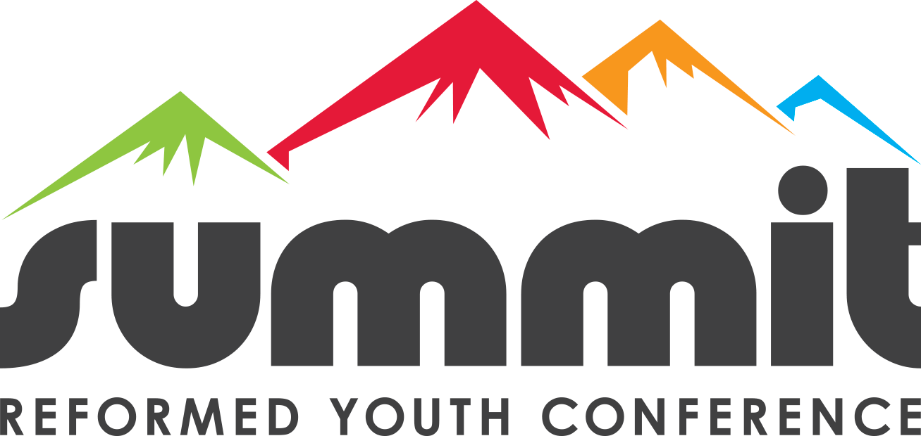
Recap for 2025
Believe it or not, we are swiftly approaching the 10th anniversary of the organization known as Summit Reformed Youth Conferences, or what we affectionately refer to as “Summit”. Summit was officially organized and launched in February of 2016. We somehow managed to host our first conference event in August of that same year. In 2020, due to the COVID lockdowns, we were unable to host a Summit Conference, so that means that Summit 2026 (Lord willing, held on August 3-6) will be the 10th Summit Youth Conference.
To help commemorate and celebrate this wonderful event, we have invited Dr. Alan Strange to return to where it all began! Dr. Alan Strange (OPC pastor and Professor and President of Mid-America Reformed Seminary) served as one of our Main Session speakers at each of the first three Summit Conferences. For 2026, Dr. Strange will team up with Rev. John Bouwers (Hope Reformed Church, URC, Brampton, ON). They will be speaking on the topic: “Counselor, Comforter, Keeper” - the Person & Work of the Holy Spirit.
Summit Recap 2025
RYAC -- February 13-16, 2025: Rev. Paul and Julie Murphy spoke at the Reformed Young Adults Conference (RYAC). 162 Young Adults attended. We had a wonderful time of worship, fun and fellowship. The organizing committee for the Young Adults conference consists of 11 young adults. They asked the Murphys to speak on the topic of “Maturity in Christ” based on the passage from Colossians 1.28: “Him we proclaim, warning everyone and teaching everyone with all wisdom, that we may present everyone mature in Christ.”
Summit Youth -- August 4-8, 2025: Dr. Joel Beeke and Dr. Jerry Bilkes served as the Main Session speakers, and they spoke on the topic of worship – “Oh Come, Let us Worship” – based on Psalm 95:6. Twelve other speakers joined them to present 14 Break-Out Sessions on various topics related to worship: Forsaking the Assembly, Worship and the Sabbath, Worship and the Nations, Cultivating Holy Habits, True Worship – More than a Feeling, Worship and the Psalms, Kindness, Worship in all of Life, Family Worship, Worthy of Worship, The True Image of God, Lessons Learned from the Mission Field, and Worship and Modern Day Idols.
Continued Growth & Blessings
To give you some perspective, at our first Summit Conference in August of 2016, we were blessed to have 160 people attend. This past August, 492 people attended! All glory, honor, and praise be to God! We are so humbled and amazed to see how God has seen fit to bless and prosper Summit over the years.
We humbly acknowledge that none of this would be possible without the blessing of God and the prayers, participation and support of our sister churches, pastors and church members in the URC, as well as growing interest and support among the Canadian Reformed Churches.
Financial Update
We give thanks to God for everyone who has so generously supported Summit! In 2025, we had a budget of $175,000. Of note, $46,000 is paid to Bethel URC for the labors of the Executive Director (Rev. Keith Davis). That is 1/3 of his annual salary, which reflects the fact that Rev. Davis commits at least 1/3 of his time to the work of organizing Summit events.
As of September 30, 2025, we have received approximately 90% of our 2025 budget, or $158,000. However, our fiscal year ended on September 1, so we fell $16,000 short of meeting our projected budget. In God’s providence, we have a healthy budget surplus from previous years, so we can cover this shortfall.
Summit Depends Upon Your Ongoing Support
We are in the process of finalizing our budget for 2026. We ask for your continued support:
- in your faithful prayers, asking God to glorify His Name through this ministry,
- in your ongoing participation (as your church sends your young people to Summit),
- in your generous contributions and donations.
For churches who have not yet done so, we humbly ask that you put Summit on your offering schedule or dedicate a portion of your annual budget to support Summit Youth Conferences.
Supporting Church Status
For 2026, we will be compiling a list of “Supporting Churches”. A Supporting Church is one that has contributed at least $1000.00 annually to Summit (through offerings or budgetary contributions. Exceptions can be made for smaller churches). Benefits we are considering:
- Only Supporting Churches can provide nominations for Summit Board vacancies.
- Youth from Supporting Churches will receive “first-in-line” status when registering for Summit events.
- Youth from Supporting Churches will pay a discounted registration fee.
*These benefits are being weighed in light of high demand/limited capacity at Summit events.

Sincerely,
Rev. Keith Davis (Pastor of Bethel United Reformed Church, Calgary AB; Executive Director of Summit Reformed Youth Conferences)

